1. short link generator with adv features

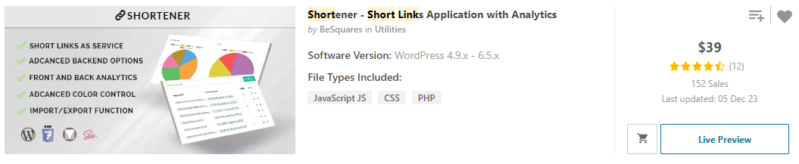

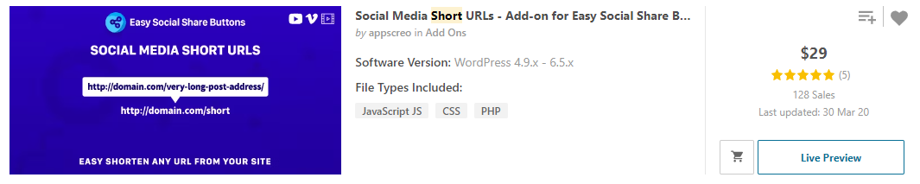

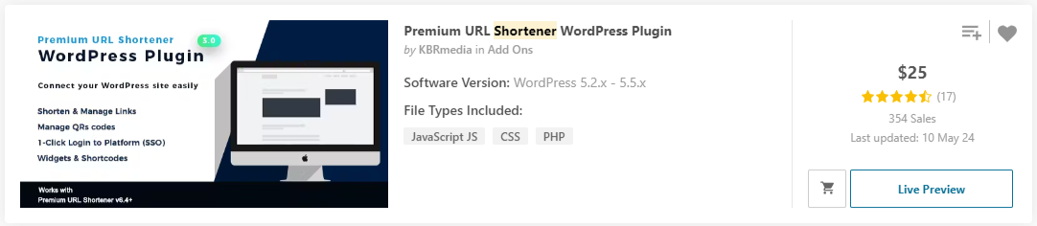

1. auto blog post

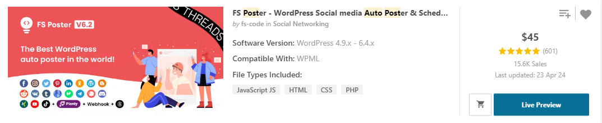

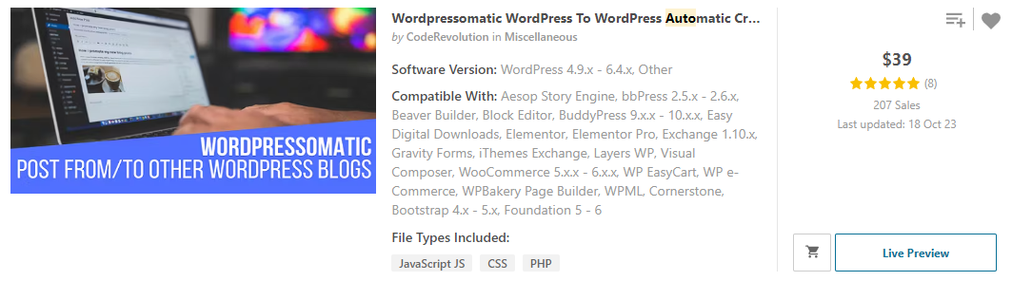

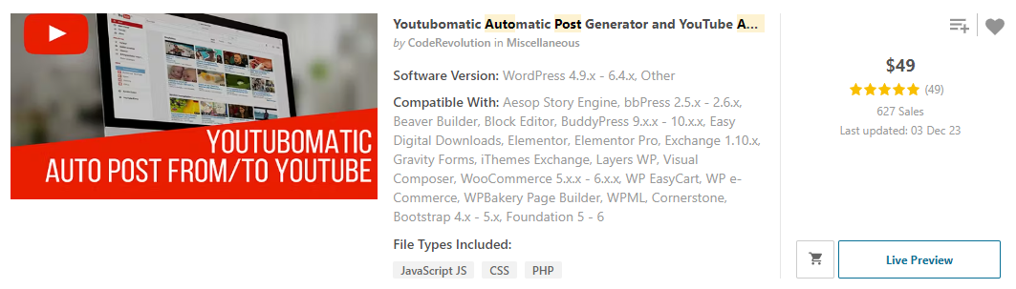

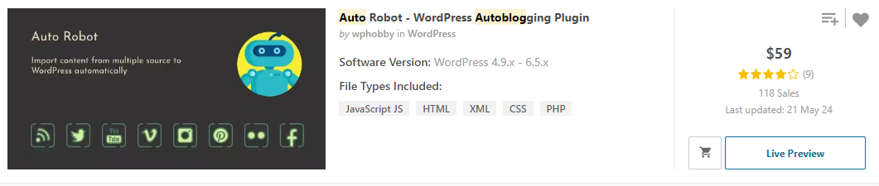

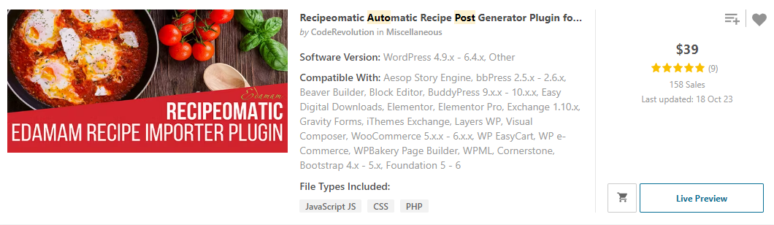

1. subscription / membership plugin

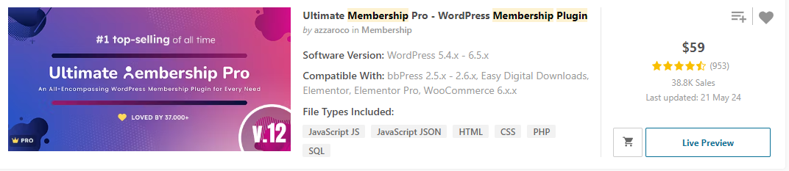

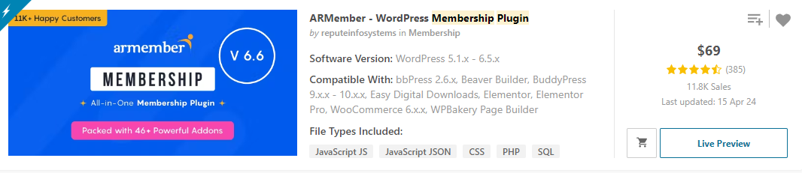

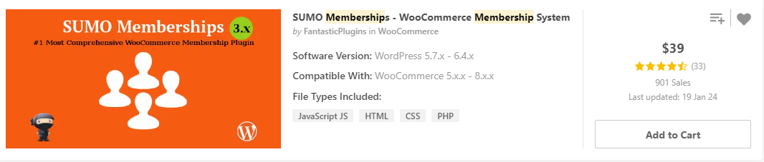

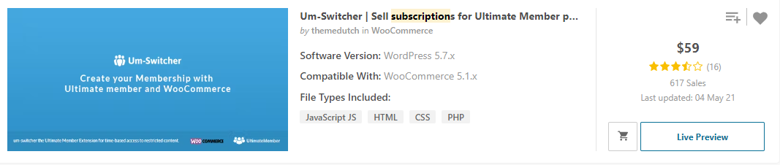

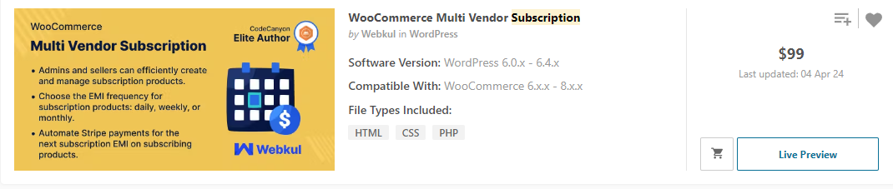

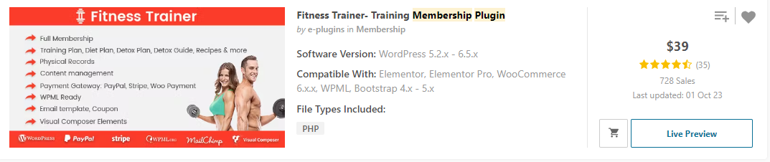

1. web view app generator

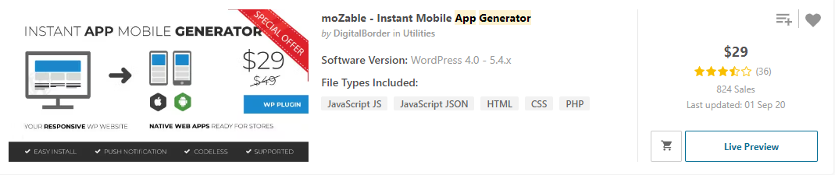

1. forum

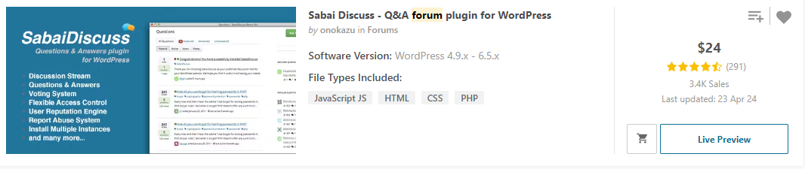

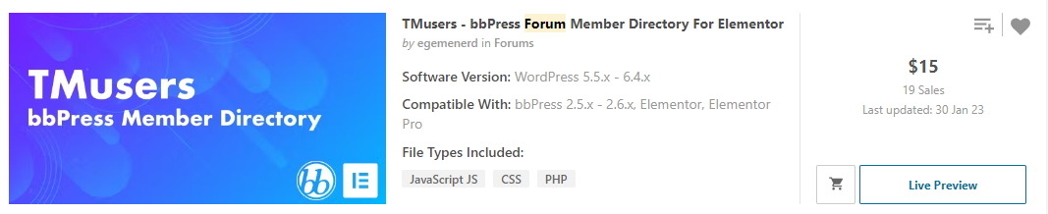

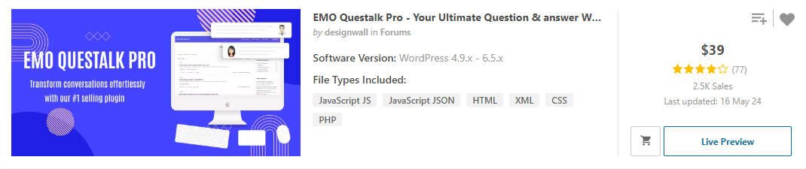

1. question and answer / FAQ

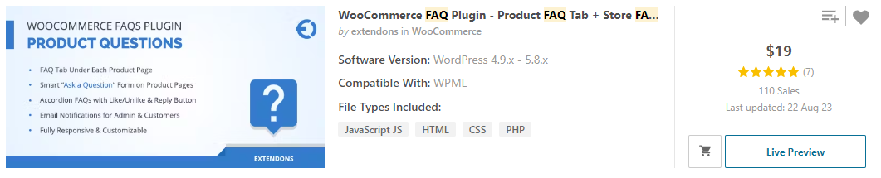

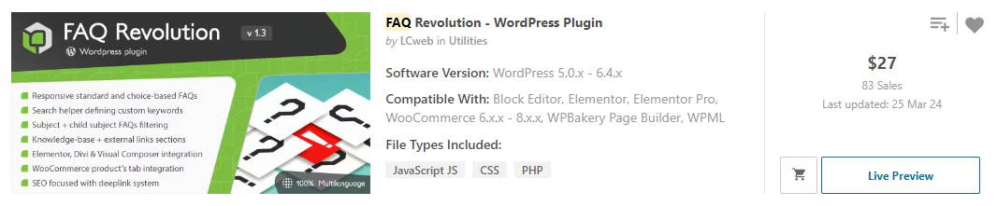

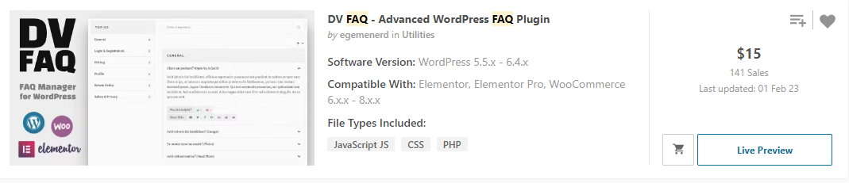

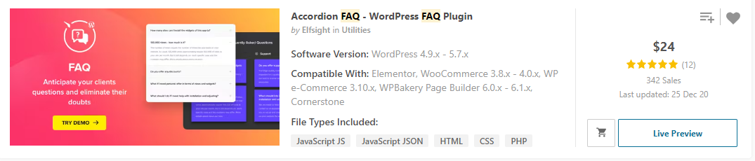

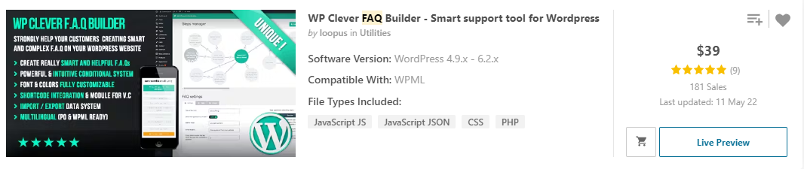

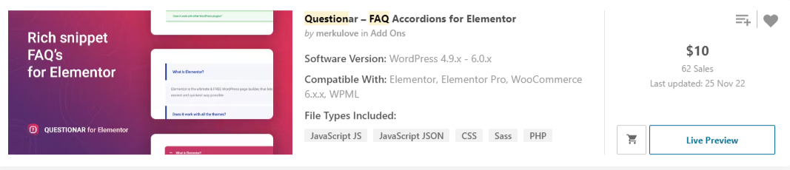

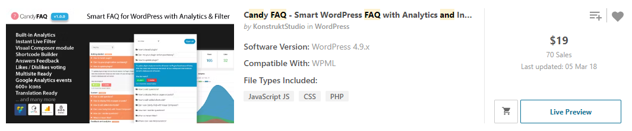

1. Order management tools with tracking system

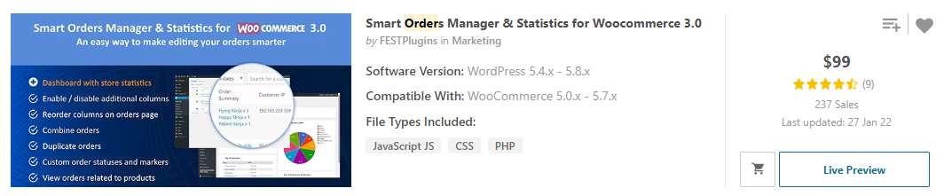

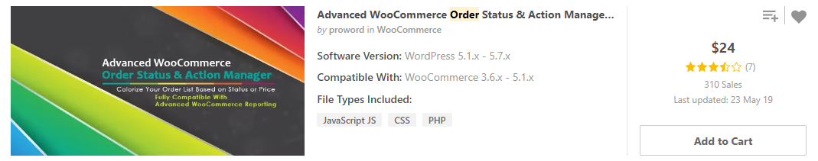

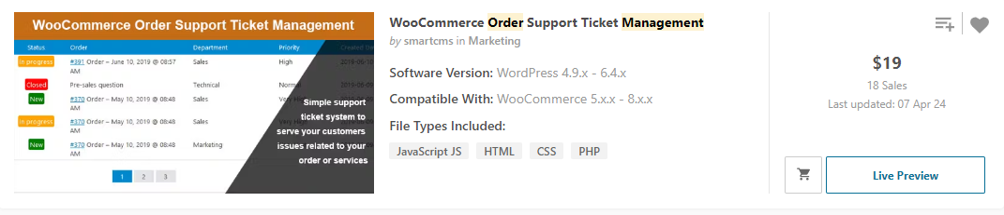

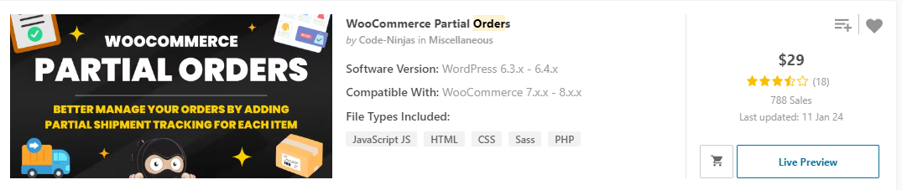

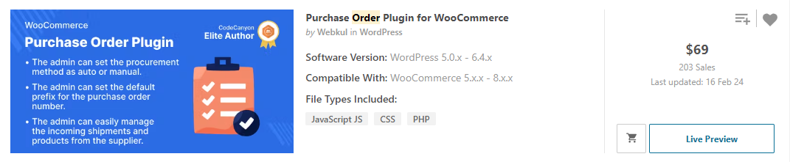

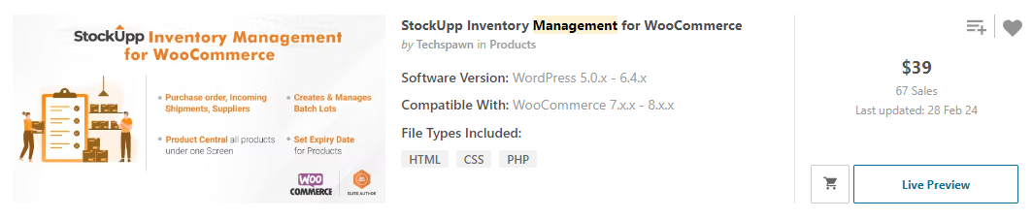

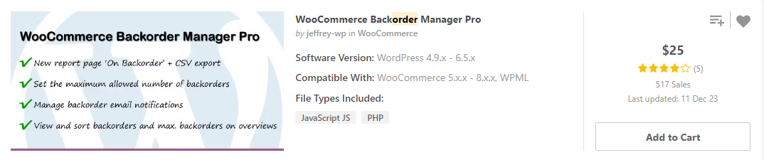

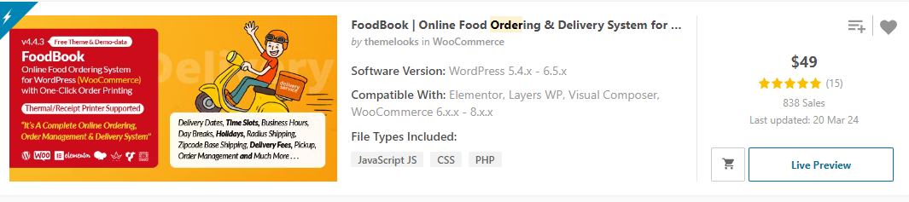

1. order page customization / print order / csv download / total report

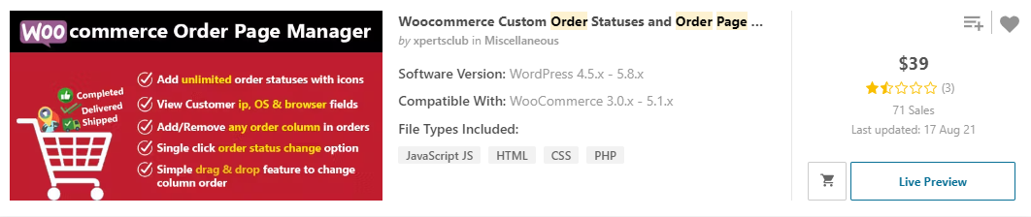

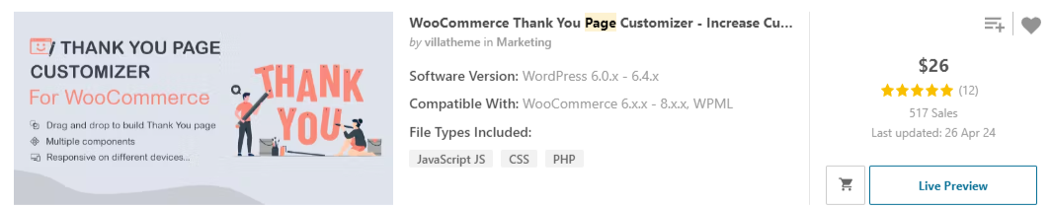

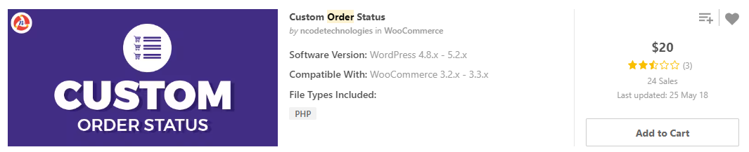

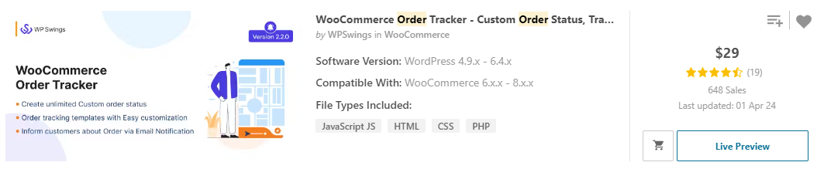

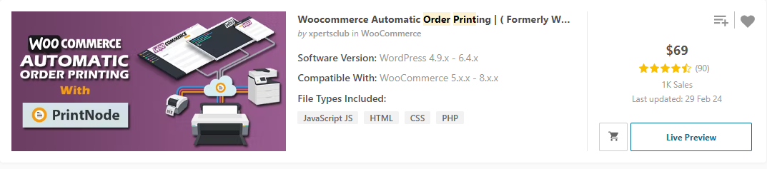

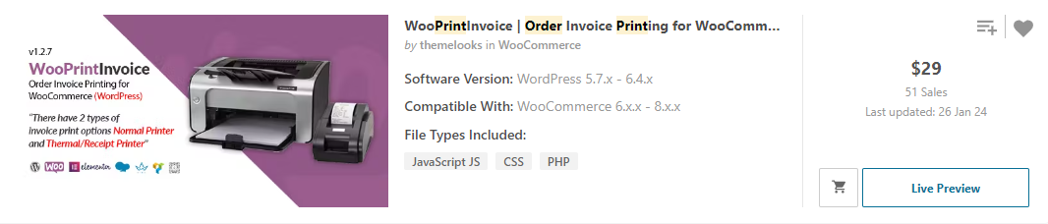

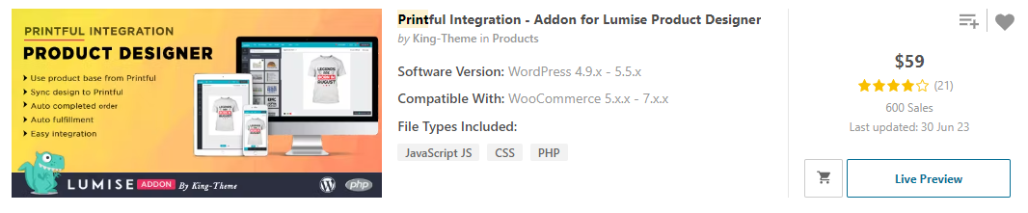

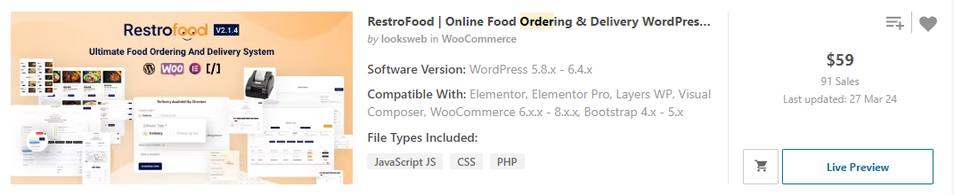

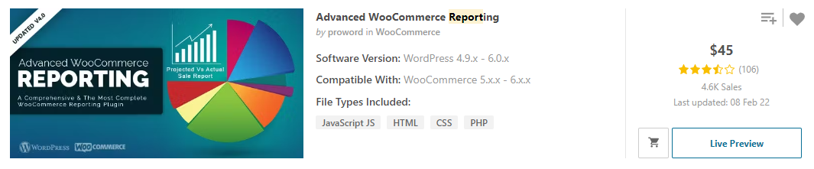

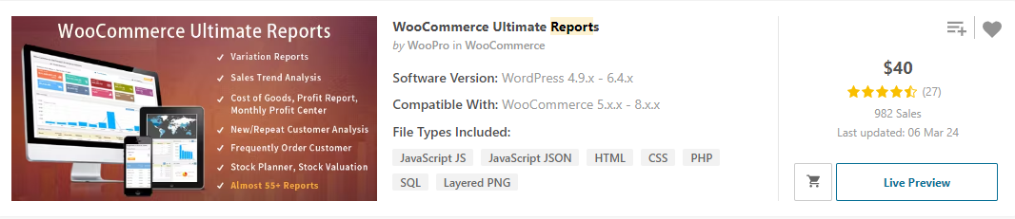

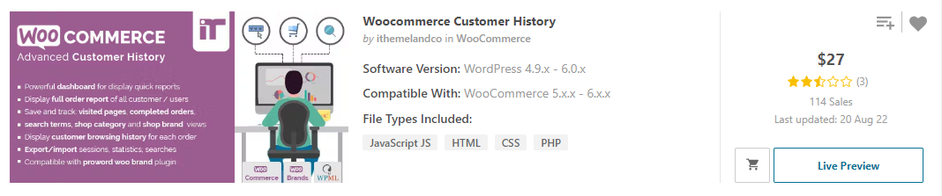

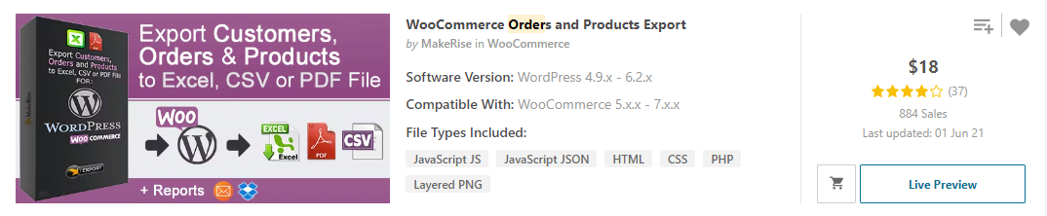

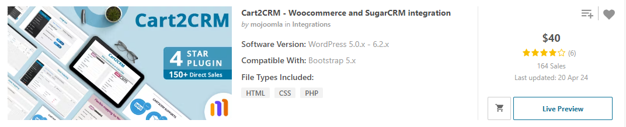

1. Affiliates system and online sale funnel

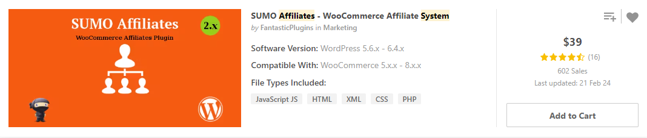

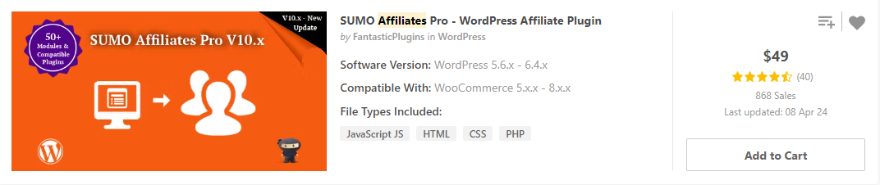

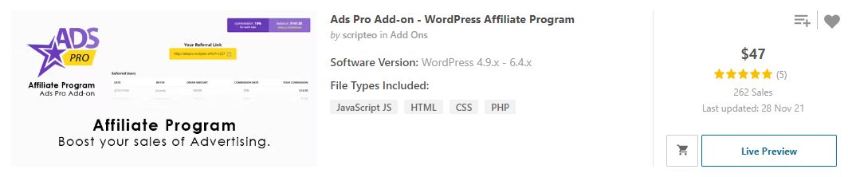

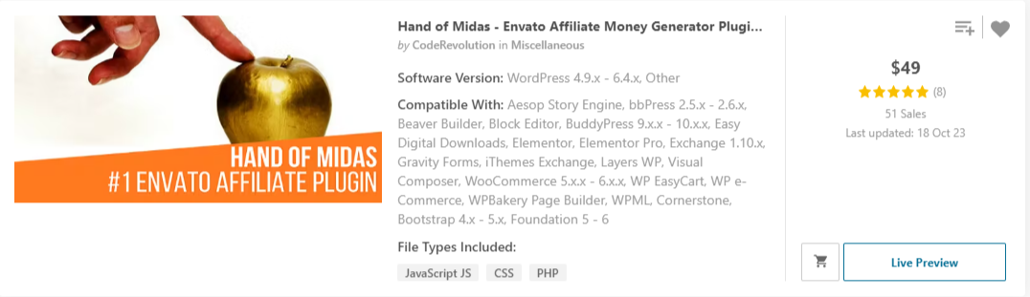

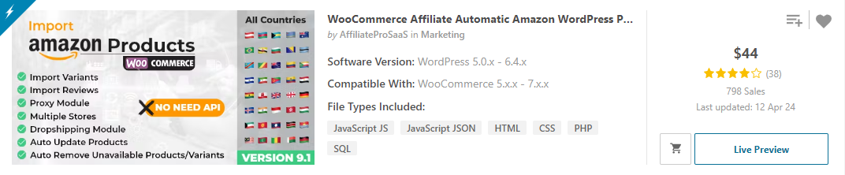



1. deposit management, chargeback handle, wallet, s2s money transfer, client trust badge

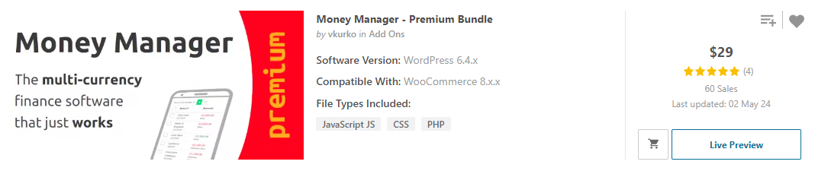

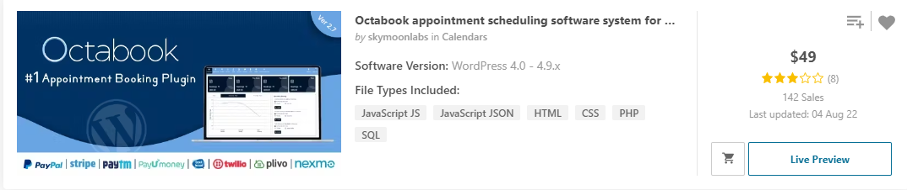

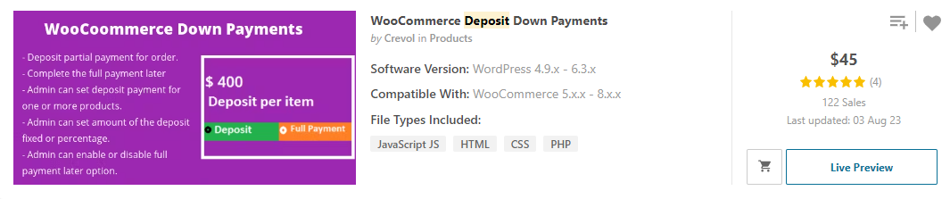

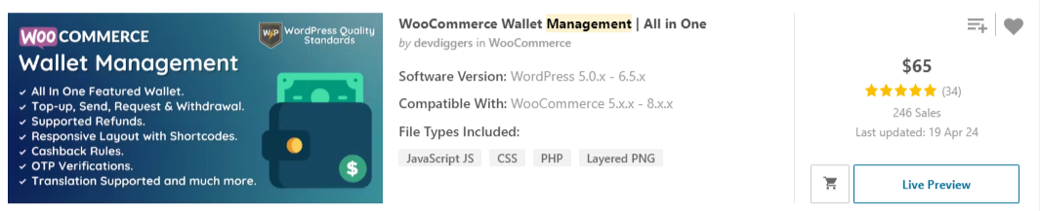

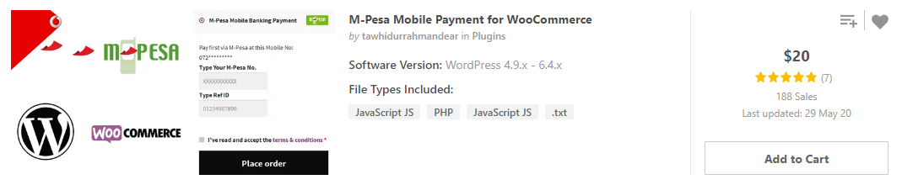

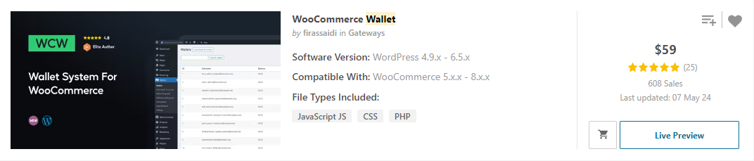

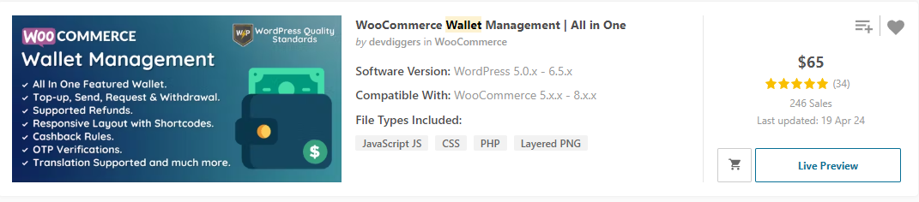

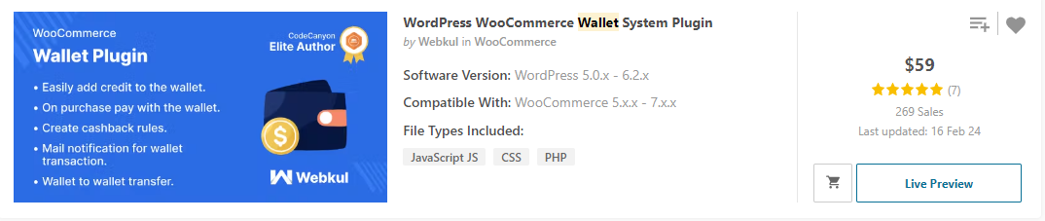

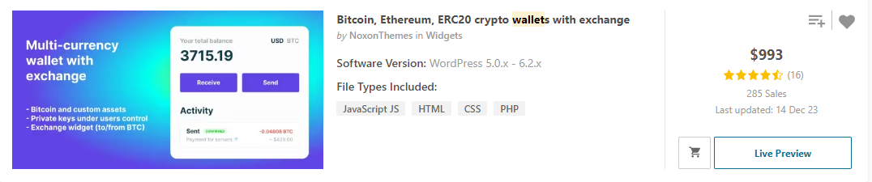

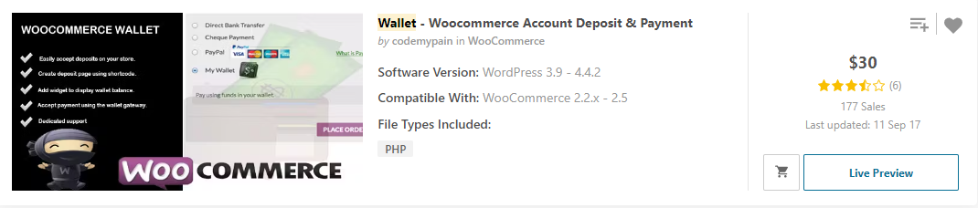

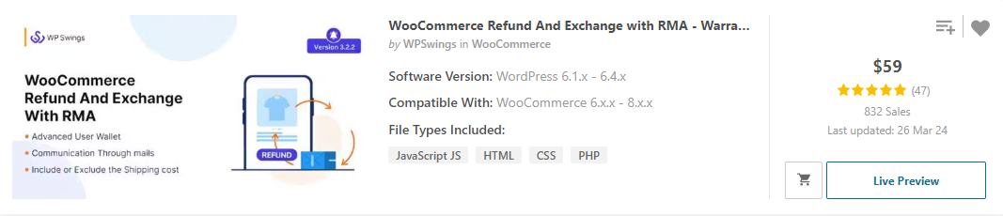

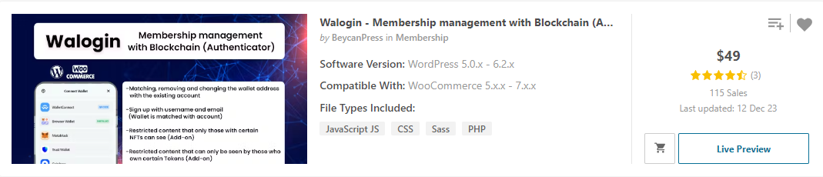

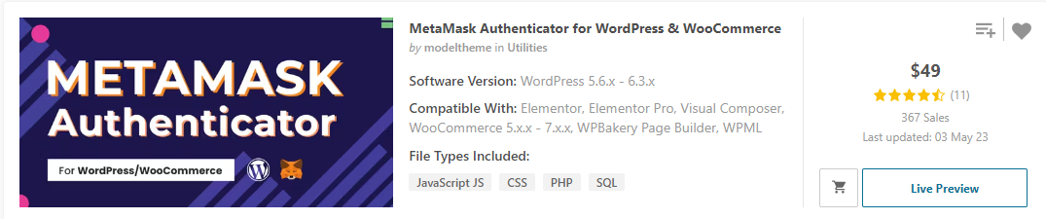

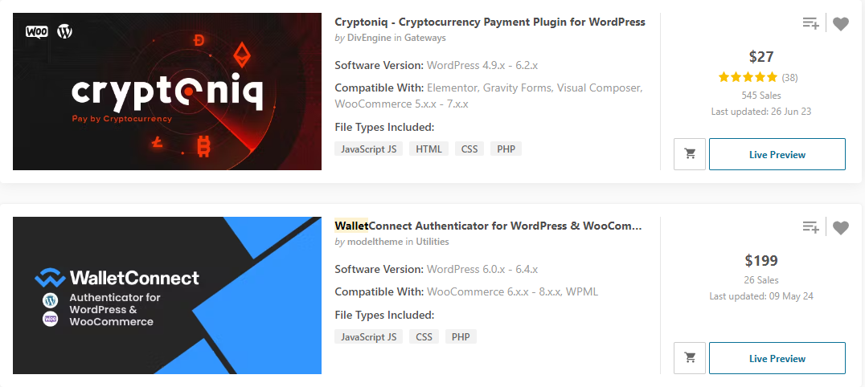

1. chatting system

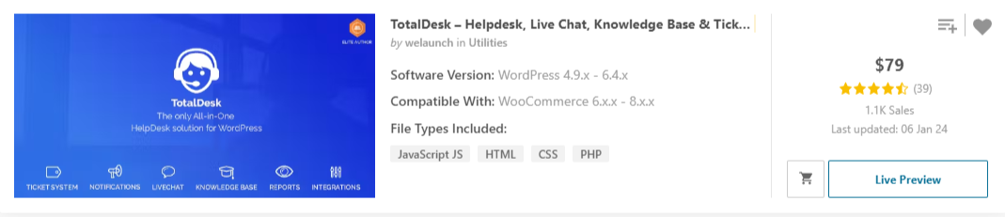

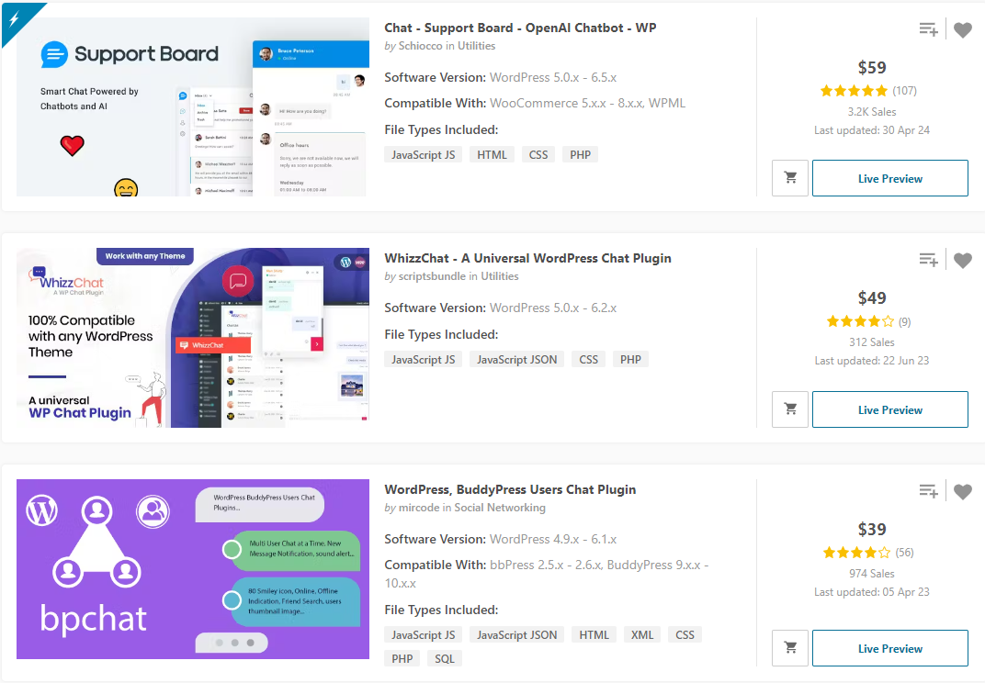



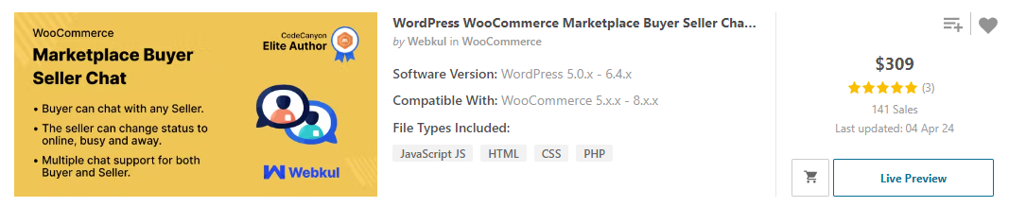

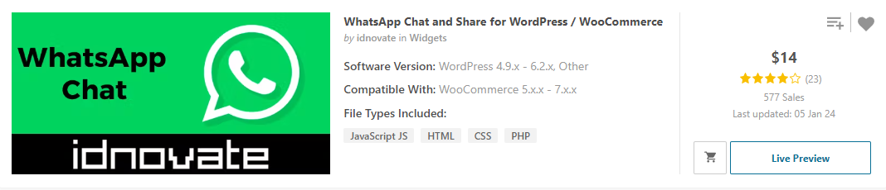

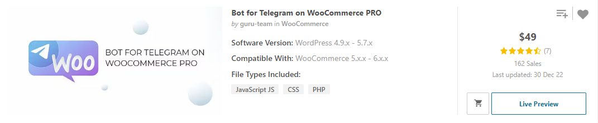

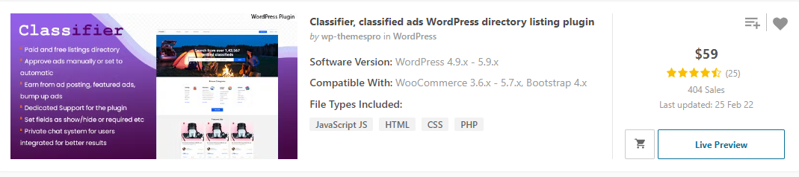

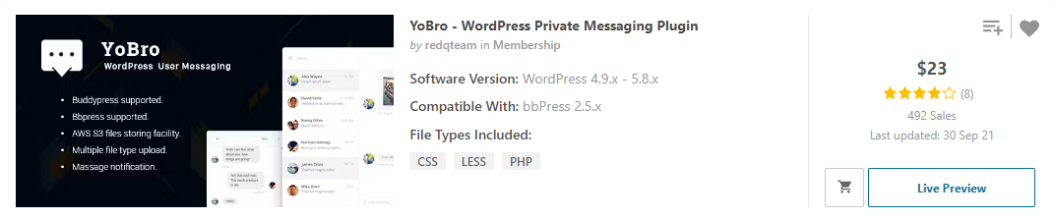

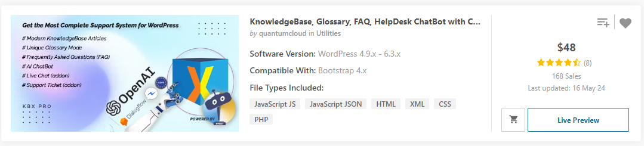

1. SEO tools, sitemap / robot generator, 404 page searcher, broken link finder, shell finder, oneclick page redirect, offline page redirect to home

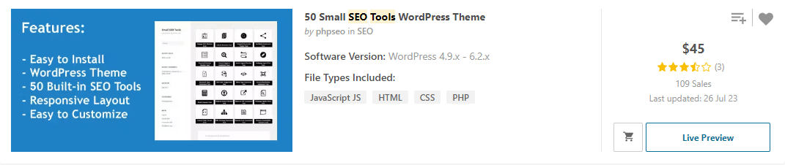

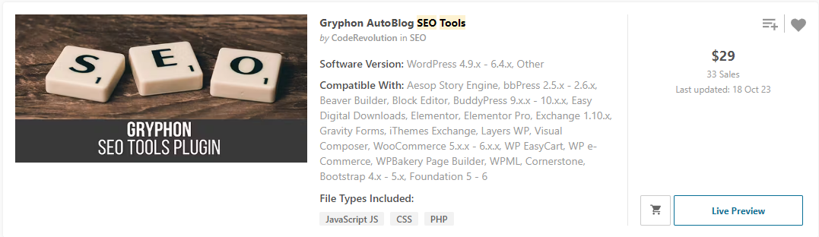

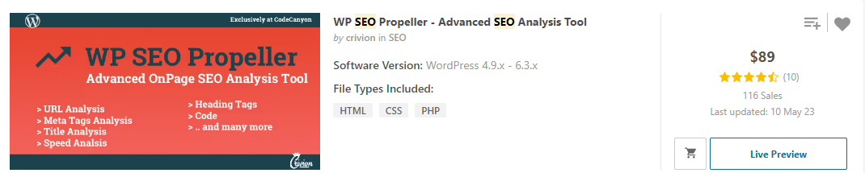

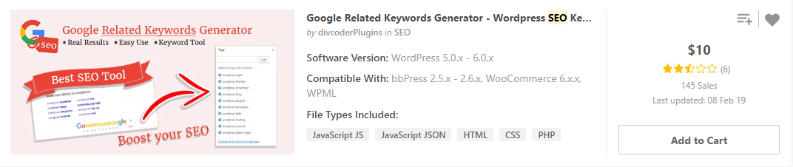





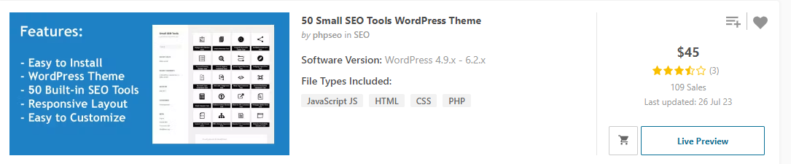

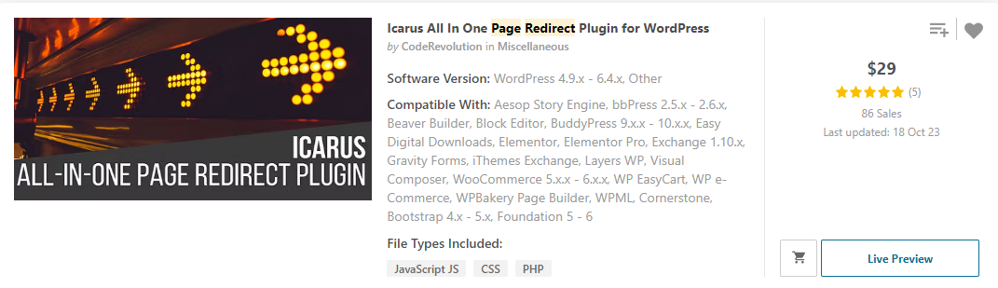

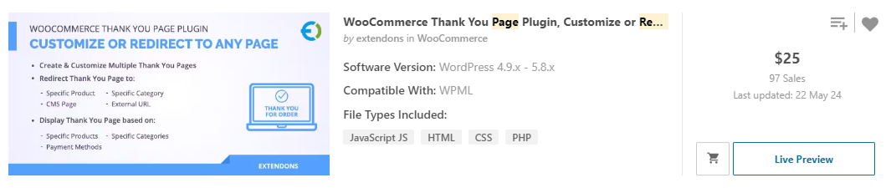

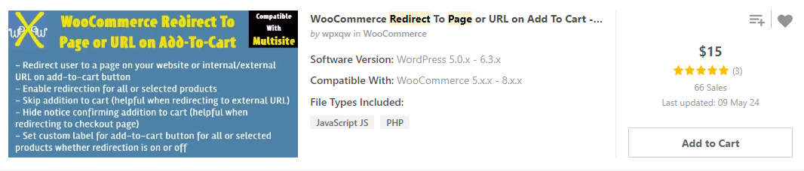

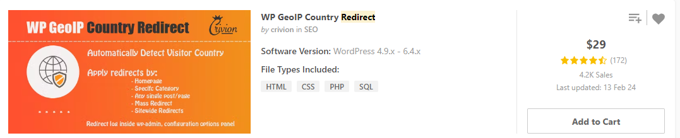

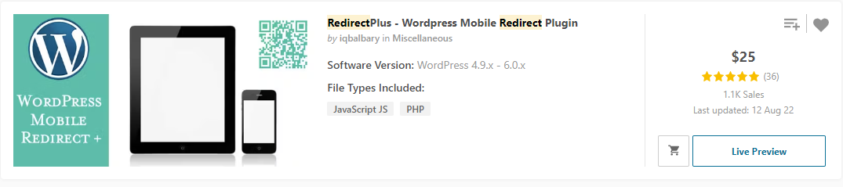

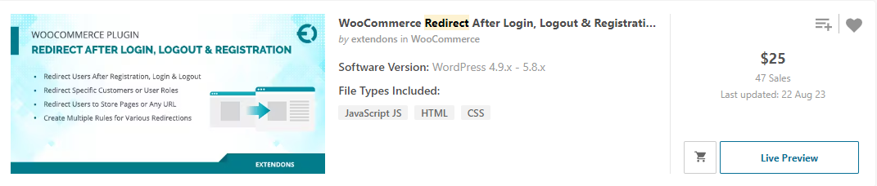

1. NFT marketplace (beshi nai)

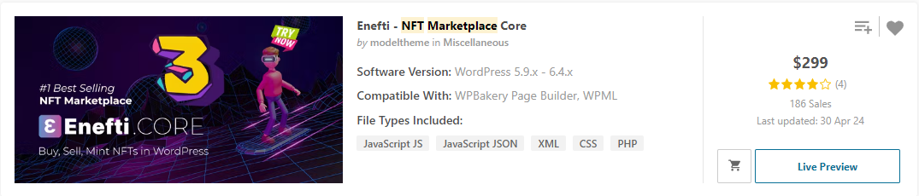

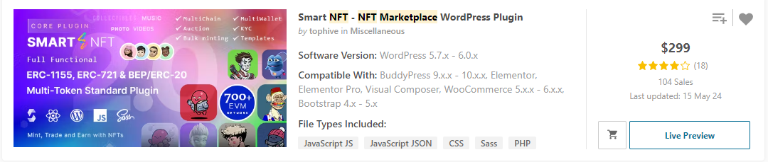

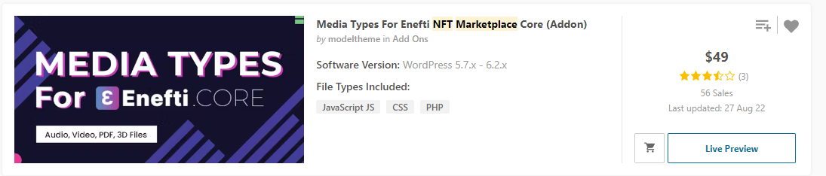

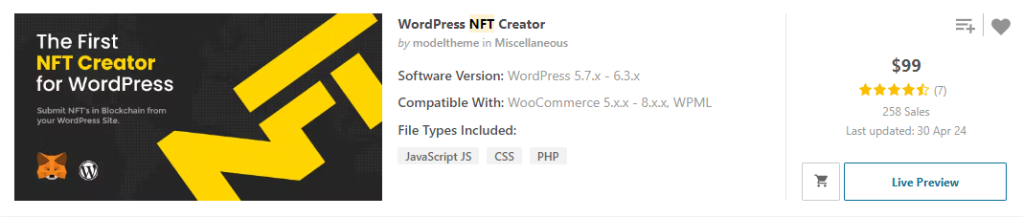

1. Digital item selling plugin

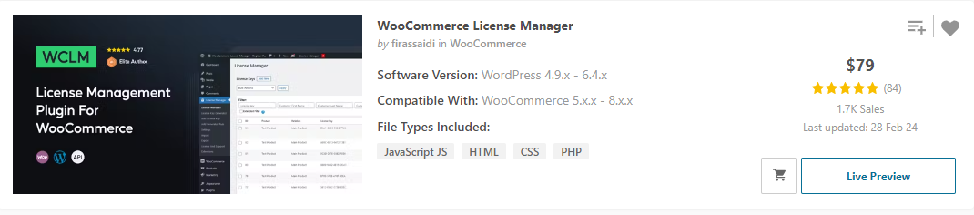

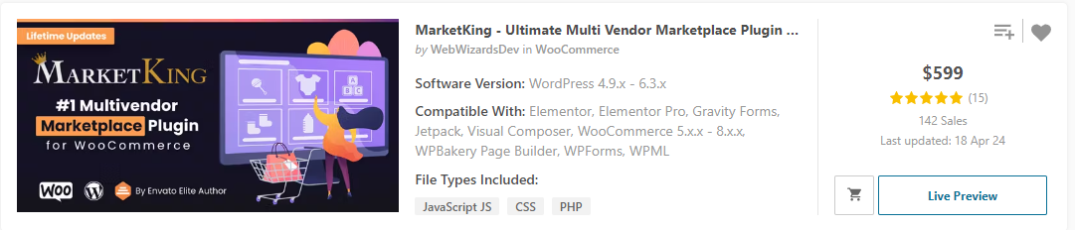

1. Pricing plan create and manage, B2b and b2c price

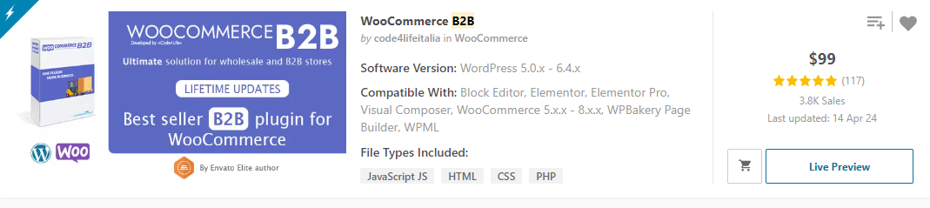

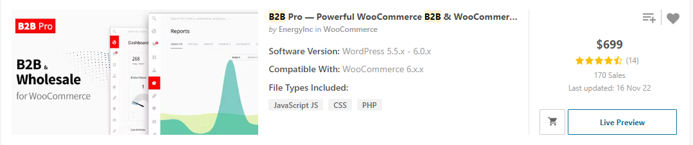

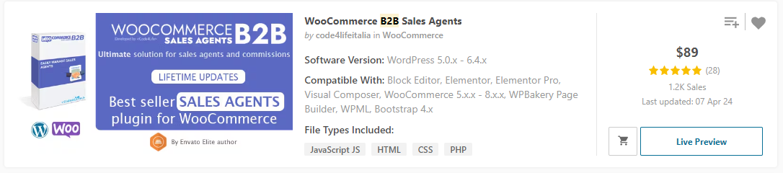

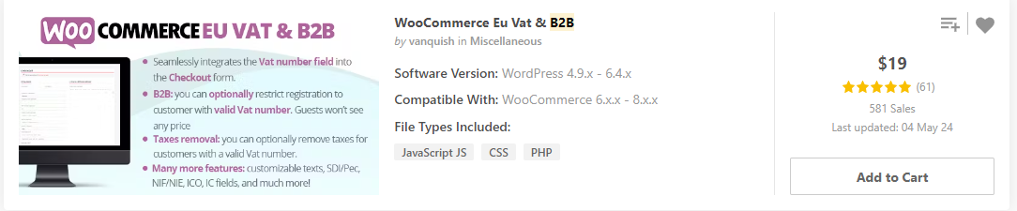

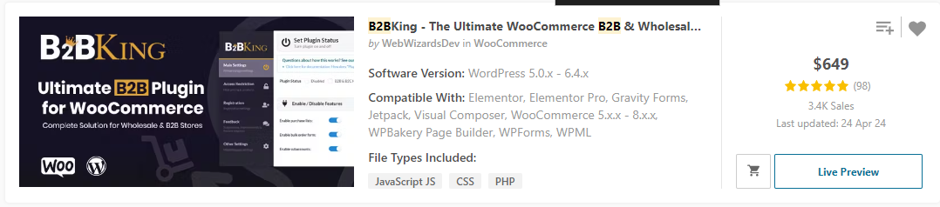

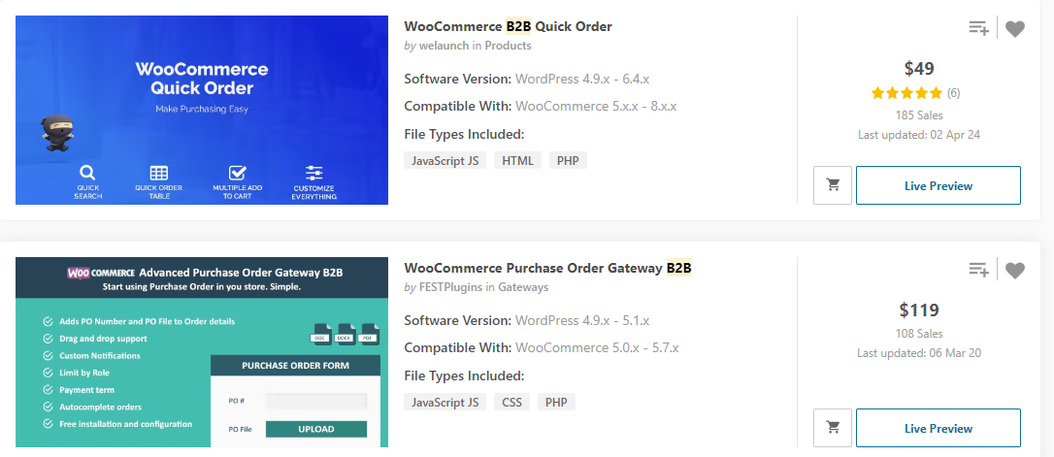

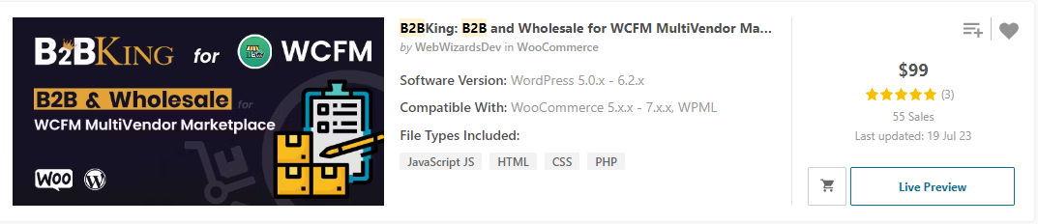



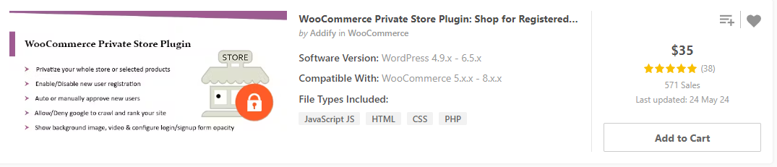

1. recurring billing management plugin

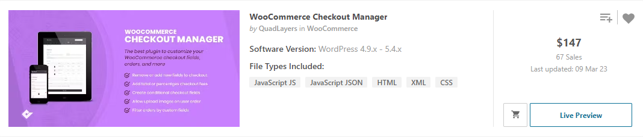

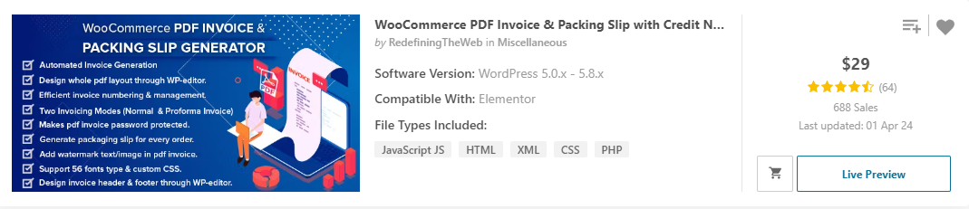

1. Donate now / donate to site

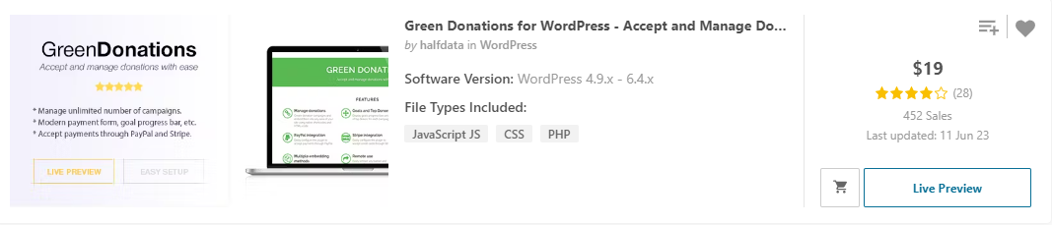

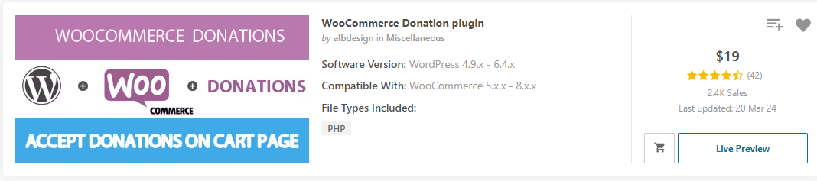

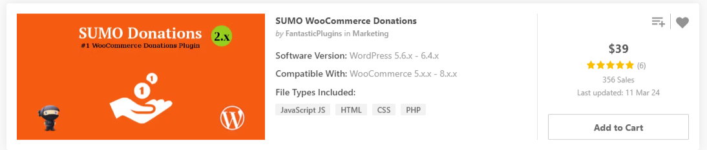



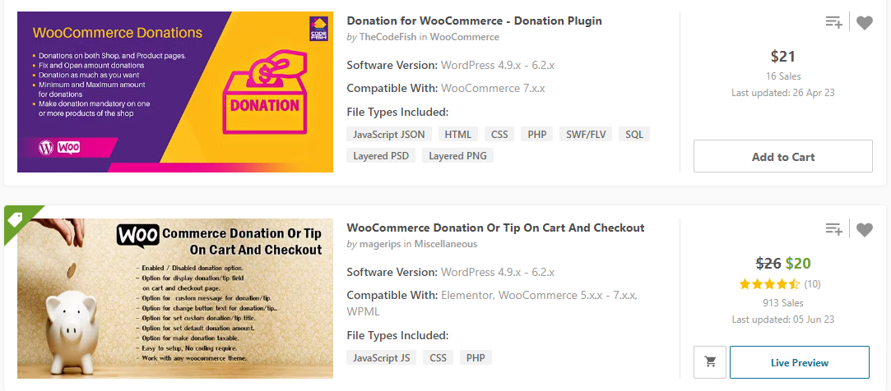

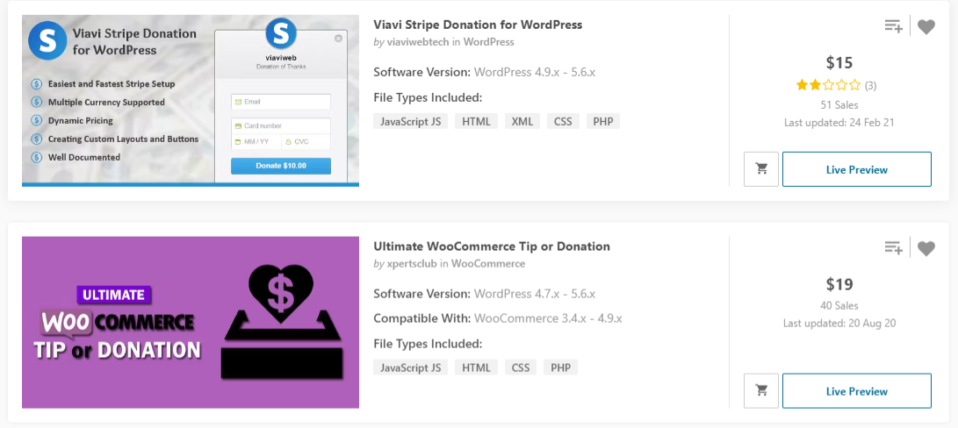

1. Live shopping, Live TV / Live Radio / live sale / live fashion

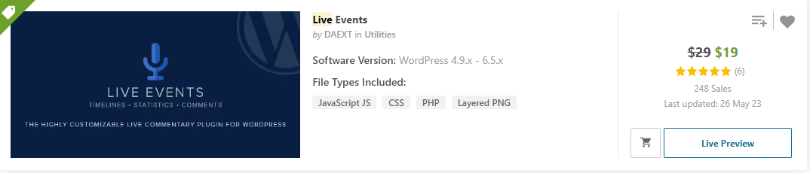

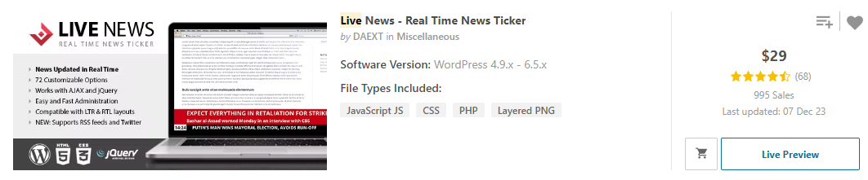

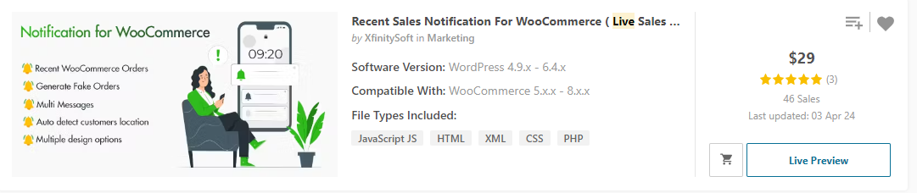

1. Staff management / ticket portal

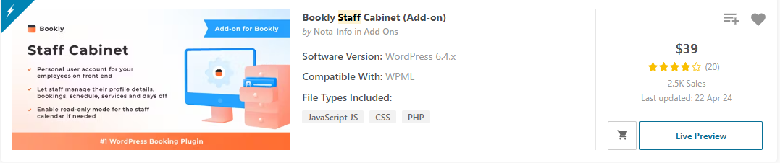

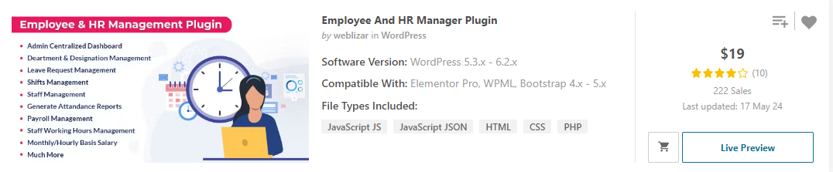

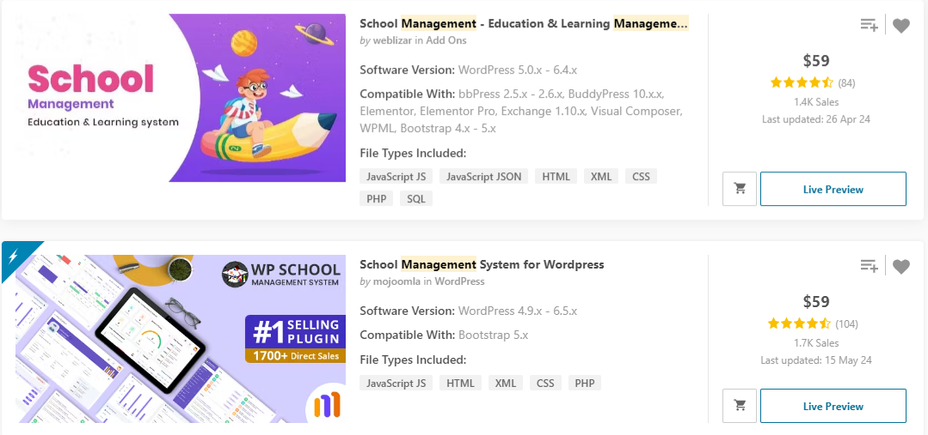



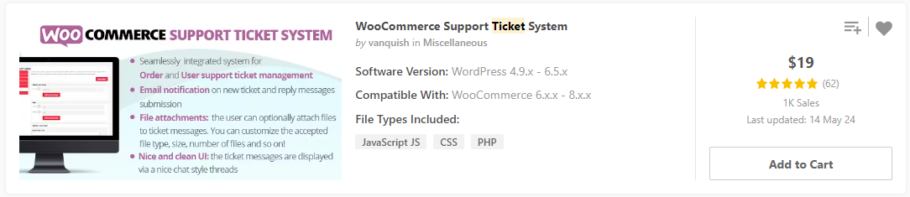

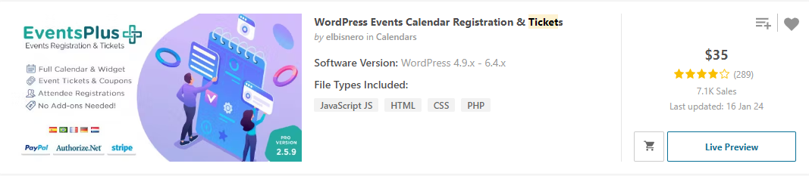

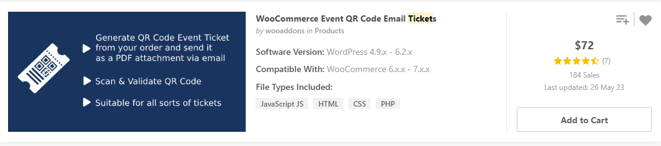

1. Product zoom / watermark

